**How to download and connect APP**

1. **APP for Android mobile(overseas)：**

Enter google play，search “keyes IoT”，if you can’t search it on app store, please download app in the following link：

**<https://play.google.com/store/apps/details?id=com.keyestudio.iot_keyes>**

1. **APP for Android mobile（domestic）：**

Download Link：<https://pan.baidu.com/s/1xE1kGjG3CroPNH3-HgF6pQ>

After installing and open the app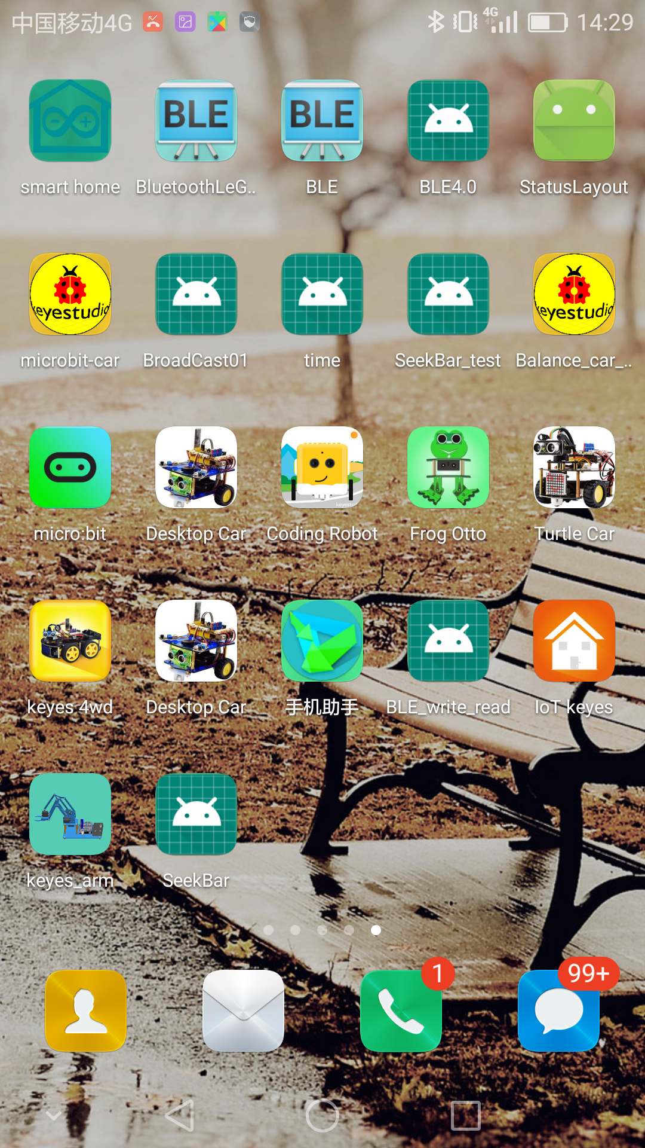，the interface pops up as below:

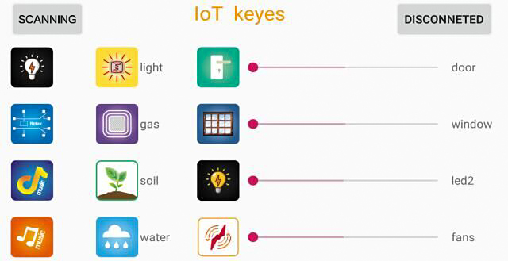

Upload code and power on, led of Bluetooth module blinks. Start Bluetooth and open App to click “SCANNING” to search and connect.

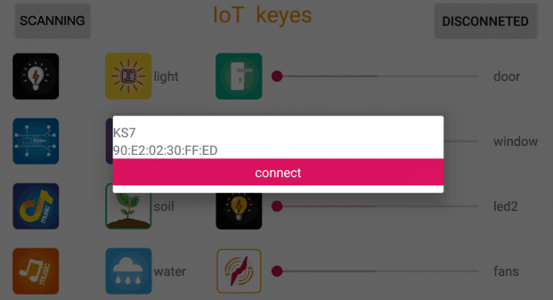

Click to “Connect”, Bluetooth is connected successfully. As shown below, the LED of Bluetooth module is always on.

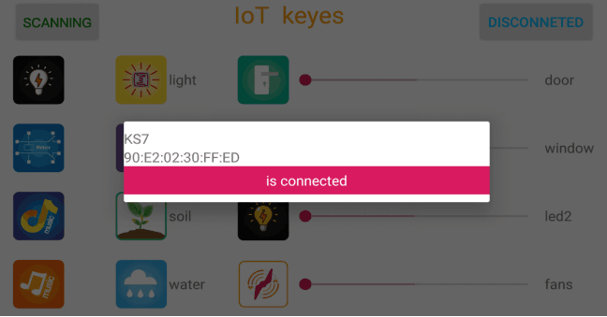

1. **For IOS system：**

(1) Open App Store.

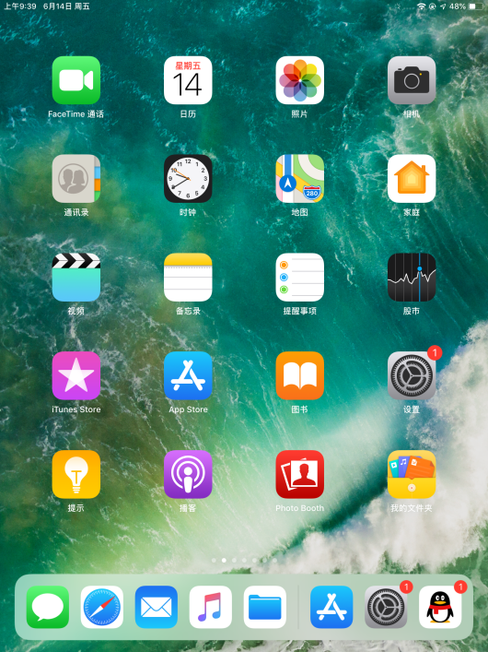

1. Search “IoT keyes”on APP Store，then click “downlaod”.

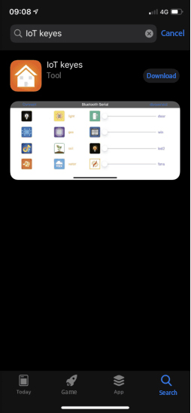

1. After installing successfully and open，the interface is shown below:

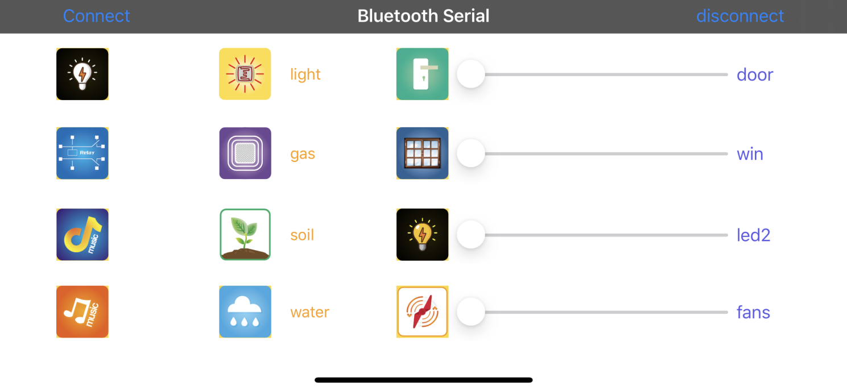

1. Upload the test code successfully, insert the Bluetooth module and power on. LED of Bluetooth module flashes. Start Bluetooth on cellphone, then click “connect” on the left to search Bluetooth and pair. After paring successfully, the LED of Bluetooth module is on.

Note: Remove the Bluetooth module please, when uploading the test code. Otherwise, the program will fail to upload. Connect the Bluetooth and Bluetooth module to pair after uploading the test code.